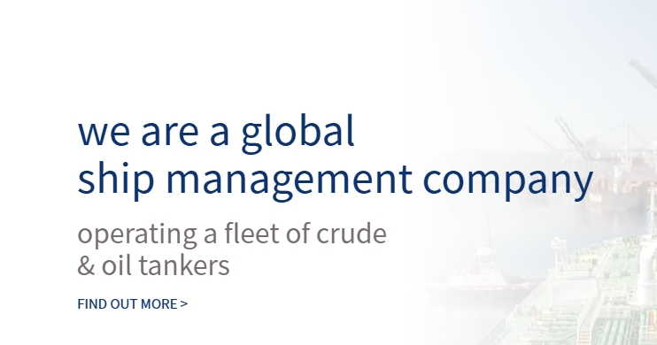
改为
We are a global
ship management company

operating a fleet of crude/Product tankers&containership

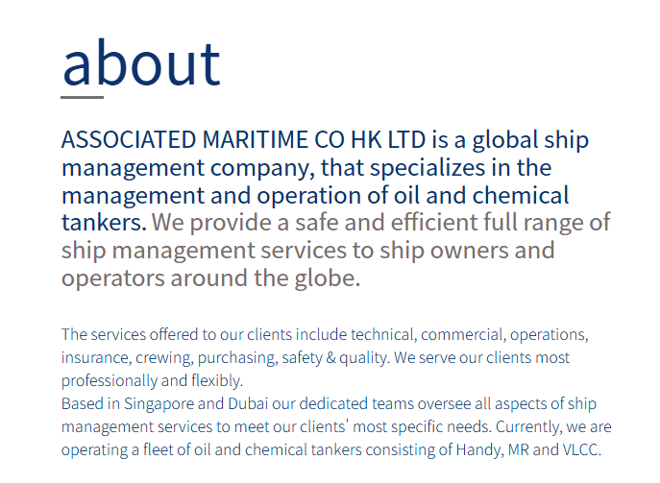
TOP MARINE GROUP is a global ship management company, that specializes in the management and operation of oil and chemical tankers、containership.
We provide a safe and efficient full range of ship management services to ship owners and operators around the globe.
The services offered to our clients include technical, commercial, operations, insurance, crewing, purchasing, safety & quality. We serve our clients most professionally and flexibly.
Based in Singapore 、Hongkong 、Shanghai our dedicated teams oversee all aspects of ship management services to meet our clients' most specific needs. Currently, we are operating a fleet of oil and chemical tankers consisting of VLCC 、Suezmax、Afra、LR 、MR and CON .

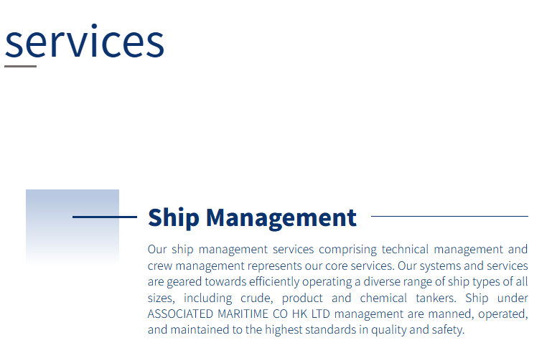
Our ship management services, comprising technical management and crew management, represent our core services. Our systems and services are geared towards efficiently operating a diverse range of ship types of all sizes, including crude, product, and chemical tankers, and containerships. Ships under TOP MARINE GROUP management are manned, operated, and maintained to the highest standards in quality and safety.

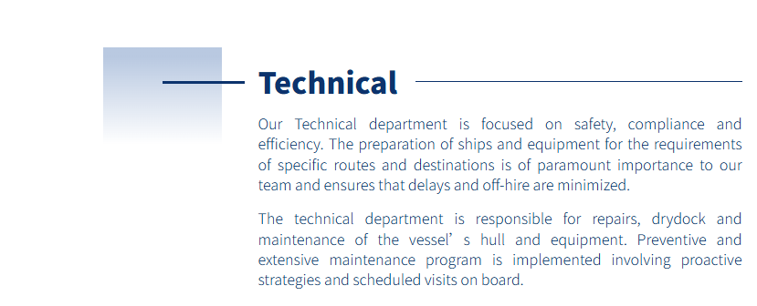

Our Technical department focuses on safety, compliance, and efficiency. Preparing ships and equipment to meet the requirements of specific routes and destinations is of utmost importance to our team, as it ensures that delays and off - hire periods are minimized.
The technical department is responsible for the repairs, dry - docking, and maintenance of the vessel’s hull and equipment. An extensive preventive maintenance program is implemented, which involves proactive strategies and scheduled on - board visits.
Our team also maintains close communication with classification societies, flag authorities and port contractors to ensure all regulatory requirements are strictly met, and all repair and maintenance work is carried out in compliance with the latest industry standards. By monitoring ship performance data and equipment operating conditions in real time, we can quickly identify potential risks and address them before they escalate into major failures, effectively extending the service life of vessels and reducing long-term operating costs for our clients.

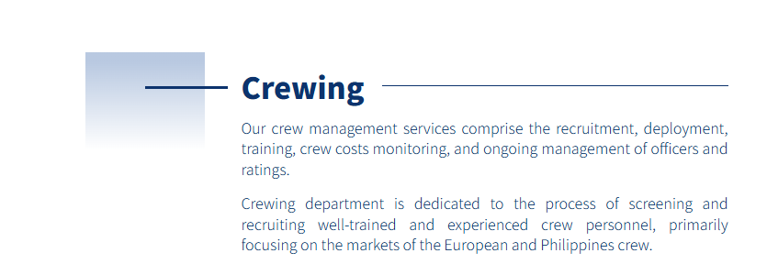
Our crew management services encompass the recruitment, deployment, training, monitoring of crew costs, and ongoing management of officers and ratings.
The crewing department is dedicated to the process of screening and recruiting well - trained and experienced crew personnel, primarily focusing on the markets of China and Southeast Asia.

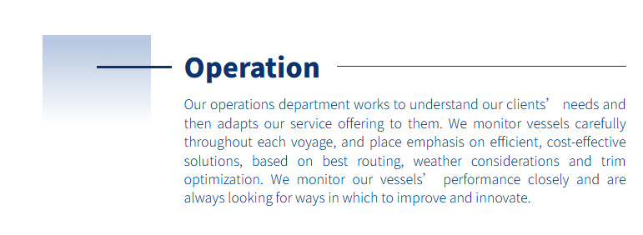

Our operations department works to understand our clients’ needs and then adapts our service offerings to them. We carefully monitor vessels throughout each voyage, placing emphasis on efficient and cost - effective solutions based on best routing, weather considerations, and trim optimization. We closely monitor our vessels’ performance and are always looking for ways to improve and innovate.

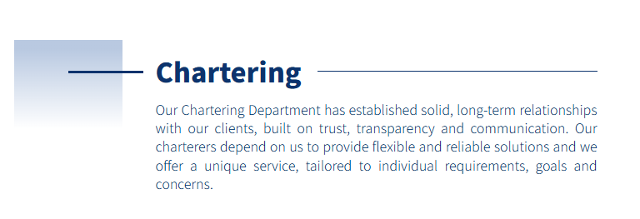
Our Chartering Department has established solid, long - term relationships with our clients, which are built on trust, transparency, and communication. Our charterers rely on us to provide flexible and reliable solutions, and we offer a unique service that is tailored to individual requirements, goals, and concerns.
Whether clients need voyage charters, time charters, or contract of affreightment arrangements, our experienced team leverages in-depth market knowledge and an extensive global network to match vessels with cargo needs efficiently. We closely monitor market fluctuations and route conditions to adjust plans promptly, minimizing operational risks and controlling costs for our clients. By maintaining open dialogue at every stage of the chartering process, we quickly address any unexpected issues and ensure all parties reach mutually beneficial outcomes, helping our clients achieve stable and sustainable maritime transportation business growth.

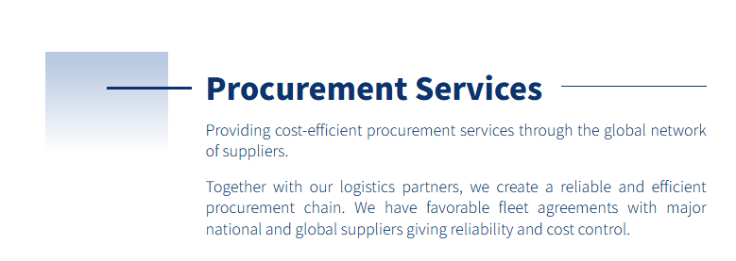
We provide cost - efficient procurement services through our global network of suppliers.
Together with our logistics partners, we create a reliable and efficient procurement chain. We have favorable fleet agreements with major national and global suppliers, which ensures reliability and cost control.
Our dedicated procurement team continuously monitors market trends and supplier performance, allowing us to adjust strategies promptly to maintain competitive pricing without compromising on product quality. We also streamline internal approval and ordering processes to cut unnecessary administrative overhead, passing these savings directly on to our clients. Whether you need small-batch custom supplies or large-volume regular orders, we can match your specific requirements while keeping your total procurement expenditure within planned budgets.

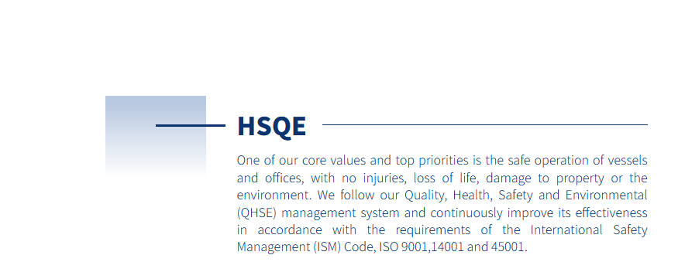
One of our core values and top priorities is the safe operation of vessels and offices, without any injuries, loss of life, damage to property, or harm to the environment. We adhere to our Quality, Health, Safety, and Environmental (QHSE) management system and continuously enhance its effectiveness in line with the requirements of the International Safety Management (ISM) Code, ISO 9001, 14001, and 45001.This commitment is embedded in every operational decision, from vessel maintenance and crew training to emergency response planning and environmental stewardship. We conduct regular internal audits, management reviews, and third-party certifications to ensure compliance and drive continual improvement. Through proactive risk assessments and data-driven performance monitoring, we identify emerging hazards early and implement corrective actions swiftly. Our QHSE culture is reinforced by leadership accountability, transparent reporting, and active employee participation across all levels.

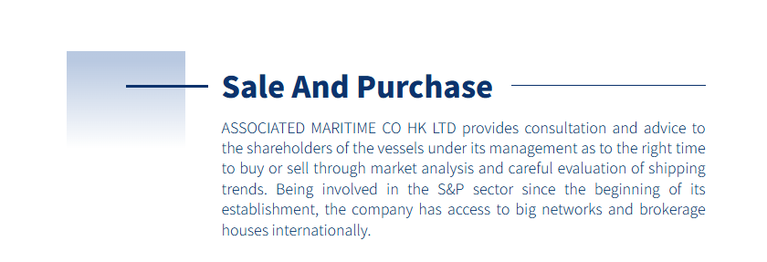
TOP MARINE GROUP offers consultation and advice to the shareholders of the vessels it manages regarding the optimal time to buy or sell through market analysis and a careful assessment of shipping trends. Since its inception, the company has been involved in the S&P sector and has access to extensive international networks and brokerage firms.
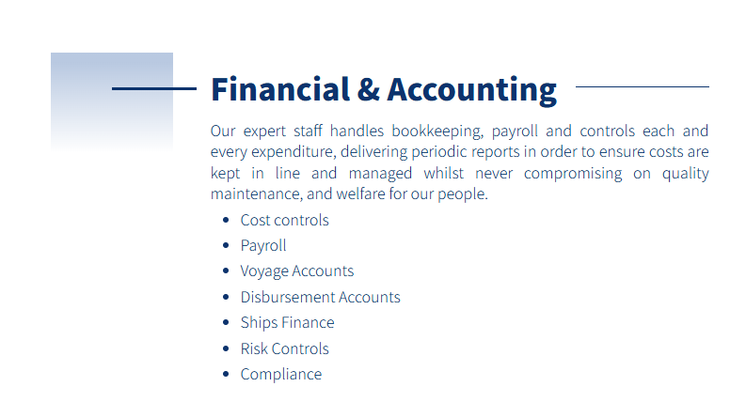
Our expert staff handles bookkeeping, payroll, and controls every expenditure. They deliver periodic reports to ensure that costs are kept in line and managed without ever compromising on quality maintenance and the welfare of our people.
- Cost controls
- Payroll
- Voyage Accounts
- Disbursement Accounts
- Ships Finance
- Risk Controls
- Compliance

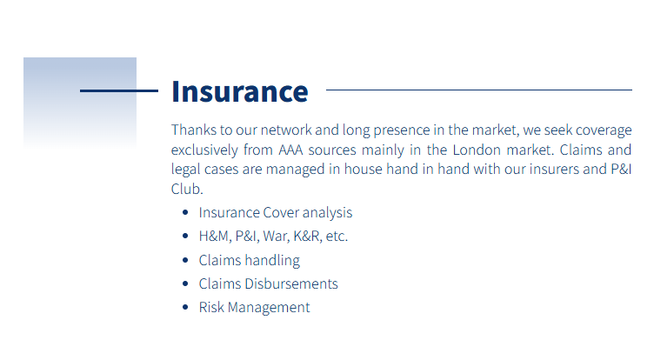
Thanks to our network and long - standing presence in the market, we seek coverage exclusively from AAA sources. Claims and legal cases are managed in - house, hand in hand with our insurers and P&I Club.
- Insurance Cover analysis
- H&M, P&I, War, K&R, etc.
- Claims handling
- Claims Disbursements
- Risk Management
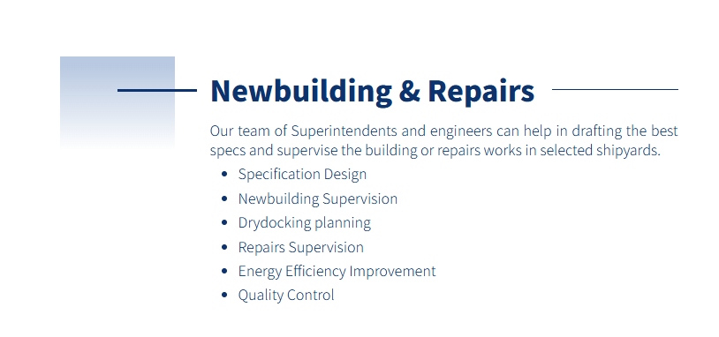
Our team of Superintendents and engineers can help in drafting the best specs and supervise the building or repairs works in selected shipyards.
- Specification Design
- Newbuilding Supervision
- Drydocking planning
- Repairs Supervision
- Energy Efficiency Improvement
- Quality Control

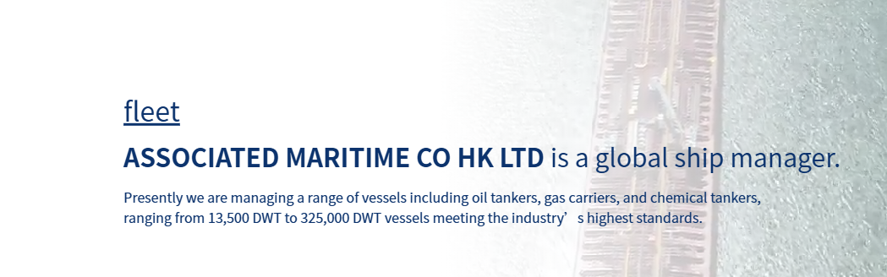
FLEET
TOP MARINE GROUP is a global ship manager.
Presently we are managing a range of vessels including oil tankers, chemical tankers, ranging from 30,000 DWT to 320,000 DWT vessels meeting the industry’s highest standards.
We also manage container ships ranging from 1,000 TEU to 4,200 TEU

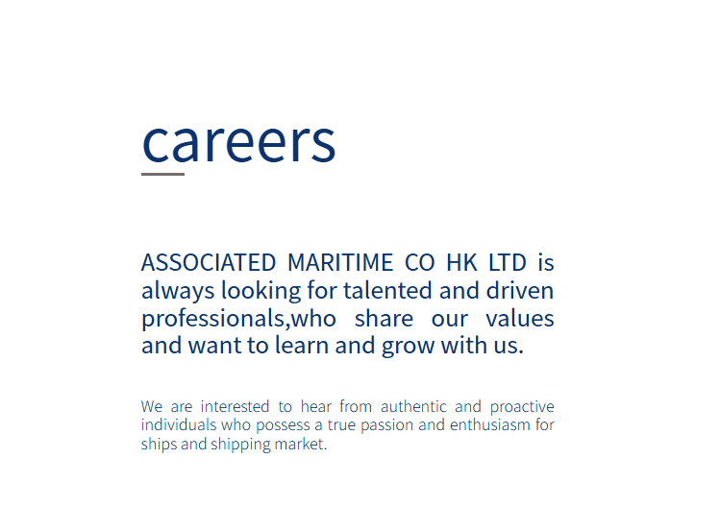
TOP MARINE GROUP is always looking for talented and driven professionals who share our values and want to learn and grow with us.
We are interested in hearing from authentic and proactive individuals who possess a true passion and enthusiasm for ships and the shipping market.
If you are ready to take on challenging responsibilities in a dynamic international environment and build your career in the ship management industry, we welcome you to submit your resume to our recruitment mailbox. We offer competitive compensation packages, comprehensive training opportunities and clear career development paths to help you achieve your professional goals alongside our growing global business.

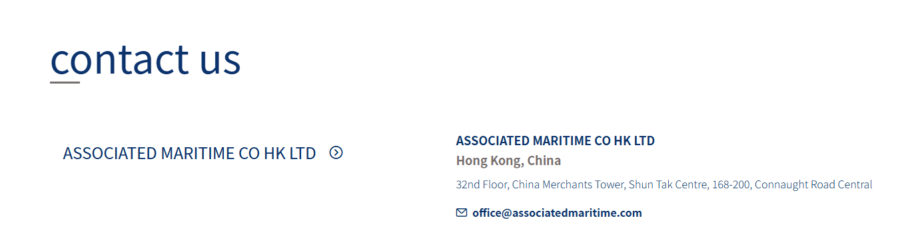
TOP MARINE GROUP PTE. LTD.
ADDRESS:163 TRAS STREET, #09-02, LIAN HUAT BUILDING, SINGAPORE 079024
ADDRESS:No. 7, Lane 855, West Huanhu 1st Road, Lingang NewArea, China (Shanghai) Pilot Free Trade Zone, Shanghai
admin@top-marine.cn

